Funeral home Facebook caption:

If your loved one or family member died from COVID-related reasons, or you believe they likely had unconfirmed COVID-related symptoms between January 20 and May 16, 2020, you may be eligible for a reimbursement of your funeral expenses. On June 29, 2021, FEMA revised its COVID-19 Funeral Assistance program, which now allows additional documentation for attributing a death to the coronavirus.

Go to https://www.funeralbasics.org/applying-fema-covid-19-funeral-reimbursement/ to learn more about how it works and how to apply.

The COVID-19 Funeral Assistance application requires:
- An official death certificate that attributes the death to COVID-19 or if the death occurred between January 20 and May 16, 2020, include both an official death certificate without COVID-19 attribution and a statement from the certifying official, coroner, or medical examiner attributing the death to COVID-19
- Funeral expense documents
- Proof of funds received from other sources

We are here to help, and our staff can meet with you to help you gather all the information needed to apply. Call us at 555-555-5555 anytime if you have any questions about this program!

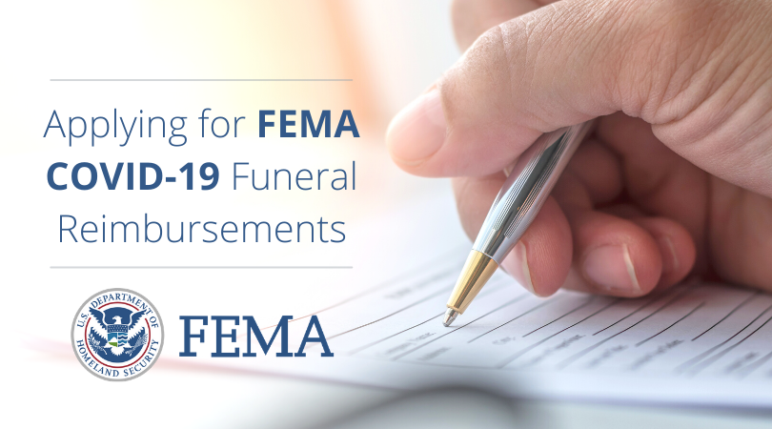

Right click on the image above and click “Save As Picture” then upload to Facebook to create the post.

